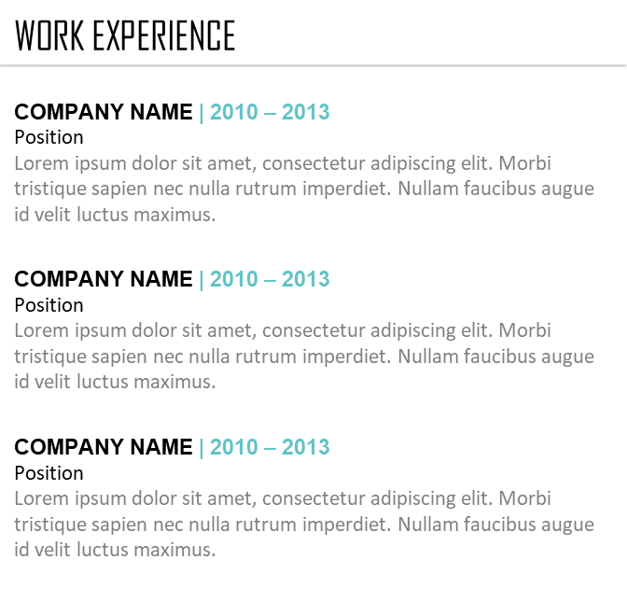
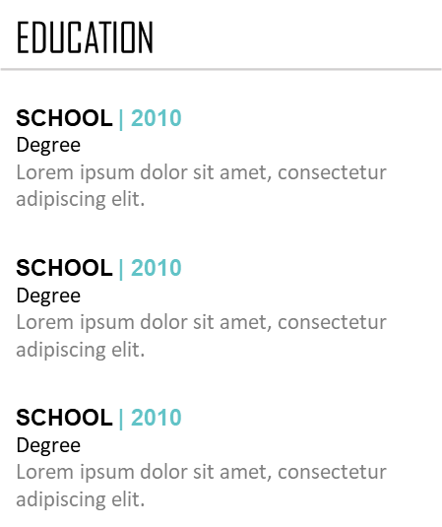









Sports
Music
Travelling
Writing
HOBBIES
LEADER
CREATIVE
ORGANIZED
PERSONALITY
Spanish
Italian
French
LANGUAGES
PHOTOSHOP
ILLUSTRATOR
FIREWORKS
DREAMWEAVER
INDESIGN
SKILLS
Yohan BENASSI
Job title
Lorem ipsum dolor sit amet, consectetur adipiscing elit. Morbi tristique sapien nec nulla rutrum imperdiet. Nullam faucibus augue id velit luctus maximus. Interdum et malesuada fames ac ante ipsum primis in faucibus. Etiam bibendum, ante nec luctus posuere, odio enim semper tortor, id eleifend mi ante vitae ex. Sed molestie
varius erat a aliquet.
12 Street Name
New York
LinkedIn.com/name
000 111 333
name@mail.com

