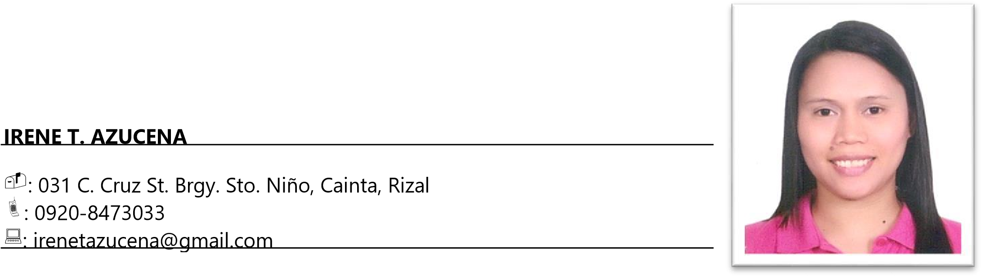
SUMMARY
Experienced in accounting processes with strong skills in organizing, communication, and attention to detail. Proficient in Microsoft Office and adept at managing financial records and reconciling accounts. Bringing multitasking abilities and a focus on accuracy to support diverse business needs.

SKILLS
- Good organizing skills
- Excellent communication and writing skills
- Computer literate (proficient in Microsoft Office Applications)
- Attention to details
- Multitasking abilities
- Account reconciliation processes

WORK HISTORY
Iprotect Consultancy and Insurance Agency, Inc.
Cainta, Rizal
Accounting Officer
August 2021-July 2025

Duties and Responsibilities
- Responsible for check preparation and check releasing.
- Maintain the completeness of disbursement reports.
- Monthly preparation of BIR deadlines.
- Responsible for the preparation of BIR Form 2307 for agents, lessors, contractors, and suppliers.

3PL Service Provider Phils., Inc.
Mercedes Ave. Pasig City
Accounts Receivable Specialist
March 2021-July 2021

Duties and Responsibilities
- Encodes and Monitors Charge Invoice for Invoice Register Book Monthly Report
- Encodes Check Vouchers for Cash Disbursement Book Reporting
- Responsible in Processing of PAL Cargo Transactions

Rublou Inc.
Rublou Business Center Cainta, Rizal
Accounting Officer
April 2019-February 2021

DUTIES AND RESPONSIBILITIES
- Responsible in check preparation and check releasing
- Check validation of sales report, collection and deposit
- Reporting of VAT Sales and Purchases
- Filing of various Bureau of Internal Revenue reports
Booze On-line Inc.
Brgy. Kasilawan, Makati City
Nov 2016 – April 2019

DUTIES AND RESPONSIBILITIES

Accounts Receivables
- Responsible in monitoring of daily receivables
- Encoding of daily sales receipts
- Receive cash and cheque collections and apply receipts in Quickbooks System
Inventory
- Encoding of daily sales receipts, returned merchandise and purchases from suppliers
- Conducting monthly physical count of stocks

Booze On-line Inc.
Brgy. Kasilawan, Makati City
Collections Head
Oct 2013 – Apr 2015

DUTIES AND RESPONSIBILITIES
- Responsible in monitoring of daily receivables
- Approves customer order
- Organizing customer files
- Prepares Statement of Account
- Call customers for collection of payment
- Monitors payments and reconciles with customer for payment with discrepancy
- Prepares Demand Letter for delinquent accounts

Nila N. Mendiola & Company
Salcedo Village, Makati City
Accountant
Apr 2013 – Sept 2013

DUTIES AND RESPONSIBILITIES
- Encoding and preparation of all necessary entries for payable and receivable transactions in Peachtree Accounting System
- Preparation of various Bureau of Internal Revenue reports( Vat, Withholding Taxes and Wages, Quarterly Income Tax Return )
- Monthly report for SSS, HDMF and PHIC remittances
- Recording of all necessary entries in General Journal, General Ledger, Cash Receipts and Cash Disbursement book
- Monthly report of Bank Reconciliation Statement

Madison Shopping Plaza, Inc.
SM City Taytay, Rizal
Accounting Assistant
Jan 2008 - Aug 2012

DUTIES AND RESPONSIBILITIES

General Accounting
- Monthly preparation of BIR deadlines
- Preparation of Cash and Bank Reconciliation
- Preparation and encoding of Journal Entry
- Amortization and depreciation of Asset account
- Checking of completeness of interfaced reports for posting in Oracle System
- Prepares Annual Reports for auditing and tax purposes
- Prepares report for Forex transactions
- Monitors attendance of Accounting Assistants and Employees Refreshment Services Attendants
- Prepares Incidence Violation Reports for erring employees in Accounting Department

Accounts Receivable
- Audit of daily transactions of Bills Payment and Bankcards
- Checking of daily transactions of Bills Payment in Oracle System
- Preparation of Monthly Billing for Affiliates and Biller Companies
- Reconciliation of payment from Biller and Bankcard Companies
- Application of payment from Affiliates, Banks, and Biller Companies in Oracle System

EDUCATION
Tertiary | Rizal Technological University-Pasig City  Bachelor of Science in Accountancy  May 2003
Secondary | Juan Sumulong Mem. Jr. College - Taytay, Rizal  March 1998
Primary | Marick Elementary School-Cainta, Rizal
March 1994

ELIGIBILITY
- CSC - Career Service Professional Examination Passer - February 04, 2004
- CSC - Career Service Sub Professional Examination Passer - April 21, 2002

REFERENCE
Available upon request.

I hereby certify that the above information is true and correct to the best of my knowledge.

Irene T. Azucena
Applicant

